Project Name:
SEDAP – South Eastern Data Analytics Platform
Company Name: Media Com Sys.
Aim: TO Create Analytics Platform for Customer’s watch time data.
- Download this file from github link provided below and start this project
- You do not need any other documentation except this video
Position 1 – Entry_ID
Position 2 – Customer_ID
Position 3 – Customer_First_Name
Position 4 – Customer_Last_Name
Position 5 – Start_Watch_Time
Position 6 – End_Watch_Time
Position 7 – Channel_Number
Position 8 – Customer_Age

- Collect Valid data in proper collection – make sure you have no duplicate element

Validation Rules:

Field | Validation Rules
Entry_ID | Non negative integer – should not repeat in single file
Customer_ID | Non-Negative Integer
Customer_First_Name | Text Only, String, 30 Character long, No Special characters
Customer_Last_Name | Text Only, String, 30 Character long, No Special characters
Channel_Number | Ranger from 100 to 1500 – non negative integer
Start_Watch_Time | Time value from 0000 to 2359. Last two digits cannot be greater than 59, first two cannot be greater than 23
End_Watch_Time | Time value from 0000 to 2359. Last two digits cannot be greater than 59, first two cannot be greater than 23  End time is greater than start time
Customer_Age | Age validation – non negative integer range from 15 to 121.

- Collect Invalid data as CSV Format – attach Error Message with original data in each row and Send this data to “SEDAP.MANUAL.ANALYSIS.QUEUE” in ActiveMQ

Original Data Row: 19,315,Treva,Womack,730,2850,880,53
Error Message Row: 19,315,Treva,Womack,730,2850,880,53, Invalid End Time Format

- Now on Day 3 – Video 3 – We have Valid set of Data. We are inserting data in DB. Please get the table schema from Github.
https://github.com/rishitrainer/SEDAP/blob/master/sedap.sql
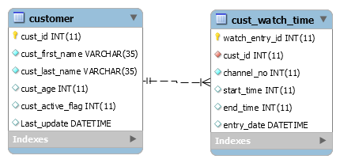
- Customer has “One to Many” relationship with cust_watch_time table
- If Customer_id is not provided in Input file, then it will be created with Auto-increment PK CUST_ID
- If CUST_ID is provided in File, use the same for insertions.
- If Data is already present for customer – update customer record with new data present in file
- CUST_WATCH_TIME table will have many entries for single customer

- Using Batch insert of normal insert is your choice, but make sure that the data should not be repeated in case of exception.

Additional Requirement:
- Can you send an email to yourself when batch completes?
Tip: Use Mail API

